|  |  |
| --- | --- |
|  | |
| DATAWAYS-COA-ALL-35-Create a Boundary Template (part 1) & DATAWAYS-COA-ALL-244-Create a Boundary Template (part 2)  Functional Specification | |
| Department: CMA CGM Commercial and Operational Allocation  Project: *DATAWAYS*  JIRA ID: *ALL-35 & ALL-244*  Author(s): Infosys | |
| Doc Reference:  Date:  Version:  Status: | DATAWAYS-COA-LT-FND-ALL-35-Create a Boundary Template (part 1) & DATAWAYS-COA-LT-FND-ALL-244-Create a Boundary Template (part 2)  21-Feb-2024 1.6 Approved |
| Classification: **Internal** | |

REVISIONS

|  |  |  |  |
| --- | --- | --- | --- |
| **Version** | **Date** | **Author** | **Subject** |
| 0.1 | 30-Jan-2024 | Savli | Document creation |
| 0.2 | 14-Feb-2024 | Savli | * Warning message before closing the tab when clicked on the breadcrumb. * Crossbar against the non-valid Port IDs in the port ID’s field in mockups * ID and Description changes i.e. Ports changed to Port ID’s, Alternative Port changed to Alternative Port ID’s, Main Boundary changed to Main Boundary (Long Leg) and Boundary changed to (Sub-Boundary) |
| 0.3 | 16-Feb-2024 | Savli | * Mockup updates * Cargo Flow side referential data on the Bounds (NB, SB, EB, WB and RT) |
| 1.0 | 21-Feb-2024 | Savli | Document Approved |
| 1.1 | 04-Mar-2024 | Savli | * Ticking option has been replaced with clicking and selecting only single option for Alternative Port ID’s. Updated BR10 and associated functional test cases |
| 1.2 | 05-Mar-2024 | Savli | * BR and associated functional test cases for Initializing ‘Generate Voyage Segmentation’ has been removed as we will be covering it in detail in ALL-38 user story and FSD. |
| 1.3 | 12-Mar-2024 | Savli | * Change of position of Error message display (BR16) * NFR BR added |
| 1.4 | 13-Mar-2024 | Savli | * Edits made in the BR18 By & Timestamp |
| 1.5 | 22-Mar-2024 | Savli | * Service ID will be fetched from the Schedule and not Master data. Changes done in Business Constraints or Assumptions section and in BR03 and the associated test cases. |
| 1.6 | 27-Mar-2024 | Savli | * User story Split |

**REVIEWS**

|  |  |  |  |  |  |
| --- | --- | --- | --- | --- | --- |
| **Name** | **Title** | **Version** | **Date** | **Company** | **Signature** |
| Prabhu SESHADRI | IT Domain Lead | 0.3 | 16-Feb-2024 | CMA CGM | Prabhu SESHADRI |
| HIENG Laurent | Product Owner | 0.3 | 16-Feb-2024 | CMA CGM | HIENG Laurent |

APPROVALS

|  |  |  |  |  |  |
| --- | --- | --- | --- | --- | --- |
| **Name** | **Title** | **Version** | **Date** | **Company** | **Signature** |
| HOELLARD Damien | Lead Product Owner | 1.0 | 21-Feb-2024 | CMA CGM | HOELLARD Damien |

DISTRIBUTION LIST

|  |  |  |  |  |
| --- | --- | --- | --- | --- |
| **Name** | **Title** | **Company** | **To** | **Cc** |
| HOELLARD Damien | Lead Product Owner | CMA CGM | X |  |
| HIENG Laurent | Product Owner | CMA CGM | X |  |
| Prabhu SESHADRI | IT Domain Lead | CMA CGM |  | X |
| Veronique JOUSSELLIN | IT Domain Owner | CMA CGM |  | X |
| Julien D’ELIA | Enterprise Architect | CMA CGM |  | X |
| Youssef ATIK | Solution Architect | CMA CGM |  | X |
| Rudy MACARONUS | Chief Architect | CMA CGM |  | X |
| Victor BONY | Project Manager | CMA CGM |  | X |
| Ganesh IYER | Proxy Product Owner | Infosys |  | X |
| Ellina GALCHENKO | Product SME | Infosys |  | X |
| Irfan KHAN | Product SME | Infosys |  | X |
| Savli TAPRE | Product SME | Infosys |  | X |
| Aishwarya RAJAN | UX Lead | Infosys |  | X |
| Tameshwar SAHU | Solution Architect | Infosys |  | X |
| Tapas SARKAR | Solution Architect | Infosys |  | X |
| Bala Chami | Scrum Master | Infosys |  | X |
| Sinchu PANICKER | PMO | Infosys |  | X |

CONTENTS

1 - Requirements 4

1.1 Document references 4

1.2 New or Modified Objects 4

1.3 Acronyms & Glossary 4

2 - Detailed Design 6

2.1 Business Context and Scope 6

2.2 Business Constraints or Assumptions 6

2.3 Functional Solution Risk 6

2.4 Requirement Details 6

2.5 Process Flow and Domain Entities 7

2.6 UI / UX Design 7

2.7 Validation and Rules 20

2.8 Setups and configurations 21

2.9 Processing definition 21

2.10 Functional Test Cases 33

3 - Technical Details (Optional) 37

# - Requirements

|  |  |
| --- | --- |
| **Requirement ID** | **User Story/Requirement Description** |
| ALL-35 | Create a Boundary Template (Part I) |
| ALL-244 | Create a Boundary Template (Part II) |

## 

### Document references

|  |  |  |  |  |
| --- | --- | --- | --- | --- |
| **Reference** | **Description** | **Version** | **Date** | **Author** |
| [ALL-36](https://cmacgm.atlassian.net/browse/ALL-36) | Maintain a list of Boundary Template | Available in JIRA | NA | Irfan Khan |
| [ALL-139](https://cmacgm.atlassian.net/jira/software/c/projects/ALL/boards/2106/timeline?selectedIssue=ALL-139) | Roles and authorization | Available in JIRA | NA | Ellina |

### 

### New or Modified Objects

|  |  |
| --- | --- |
| **Components involved and purpose (Part of technical Document)** | |
| Screen ID xxx |  |
| API Name xxx |  |
|  |  |
|  |  |
|  |  |
|  |  |

### Acronyms & Glossary

|  |  |  |
| --- | --- | --- |
| **Term** | **Acronym** | **Definition** |
| Schedule Bounds | Schedule Bounds | A schedule bound is a segregation of a technical voyage into separate blocks that indicate the direction of the vessel sailing.  Schedule bounds have a 1:1 relation with a Commercial Voyage Number (CVN).  Possible values for a bound are:  WB-Westbound; EB-Eastbound; NB-Northbound; SB-Southbound; RT-Roundtrip |
| Boundary Port | Boundary Port | A boundary is a port of the port call sequence of the voyage which is a marker for commercial performance.  There are two types of boundaries:   * A simple boundary is a point of measurement of the commercial performance, whereby some long leg bookings are on board at its departure, but some short leg bookings may also be loaded. * A main boundary is a point of measurement of the commercial performance, whereby only long leg bookings are on board at its departure. |
| Port | Port | * Ports are commercial places on the coastline that are used for import/export of goods from one country to another, generally, there are facilities for the loading & unloading of the ship. |
| CVN | CVN | * Commercial voyage numbers (CVNs) are used in addition to voyage numbers to identify a voyage on the bound level. CVNs contain information about the voyage, which is useful for business purposes (for example, from the CVN you can tell who is the carrier for the voyage). * CVNs are composed of nine alphanumeric characters and follow a fixed format that you must configure for each line. You assign CVNs when you are generating voyages and you also have the option to edit the CVNs for voyages. Each character in a CVN represents a piece of information about the voyage. The system uses statuses to track the life cycle of CVNs. |
|  |  |  |

# - Detailed Design

### Business Context and Scope

As part of DataWays program, a boundary template is to be built. The scope of this document is to cover the functionality which will support the creation of the boundary template for any existing service from the schedule. The purpose of this boundary template is to assign Sub-boundary, Main Boundary (Long Leg), bounds to the group of ports for a service. The access to this template is limited to authorized users. The template will have service ID, version ID, Port ID’s, schedule bound, boundary type, alternative Port ID’s, valid from date, valid to date, save and cancel button.

### Business Constraints or Assumptions

* Service ID should be present in the schedule.
* Port IDs should be present in the master data which can be used in the new application.
* Only authorized user can access and create the boundary template.

Note: Roles and authorization i.e. who can access the template will be covered in a separate user story ALL-139

### Functional Solution Risk

N/A

### Requirement Details

As per the business requirement, an authorized user should be able to create the boundary template. It will be a screen defining boundaries for voyages, based on the following attributes

* Service ID
* List of port ID’s
* Schedule Bound
* Boundary type (Sub-boundary/Main boundary (Long Leg))
* Validity

Once the authorized user updates all the mandatory field based on the above attributes and all the validation checks are done, the user can save the template and the new boundary template gets created.

### Process Flow and Domain Entities

### UI / UX Design Please refer to the figma file for the new mock-ups

[HAND OFF FILE DATAWAYS COA – Figma](https://www.figma.com/file/mlb3qA6iLdkguaBnRgbNEw/HAND-OFF-FILE-DATAWAYS-COA?type=design&node-id=0-1&mode=design&t=mP89tEQFt6tyj4li-0)

* Home Page navigation to boundary template

* Button to create a new boundary template

* Boundary template creation screen

* Entering the Service ID

* Entered Service ID not present in the schedule

* Boundary Template already exist for a service entered in the service ID

* Boundary Template already exist for a service entered in the service ID - error message

* Selecting port ID or port ID’s using autosuggestionA screenshot of a computer

  Description automatically generated

* Port ID’s pop-up search using autosuggestion.

* Port ID’s pop-up search without autosuggestion

* Entered Port ID is not defined in master data

* Port ID’s field will get populated with the selected port ID’s

* All the Port Boundary Table fields appear once the port ID’s column is populated and mandatory fields get highlighted in red

* Cancel creation of the boundary template

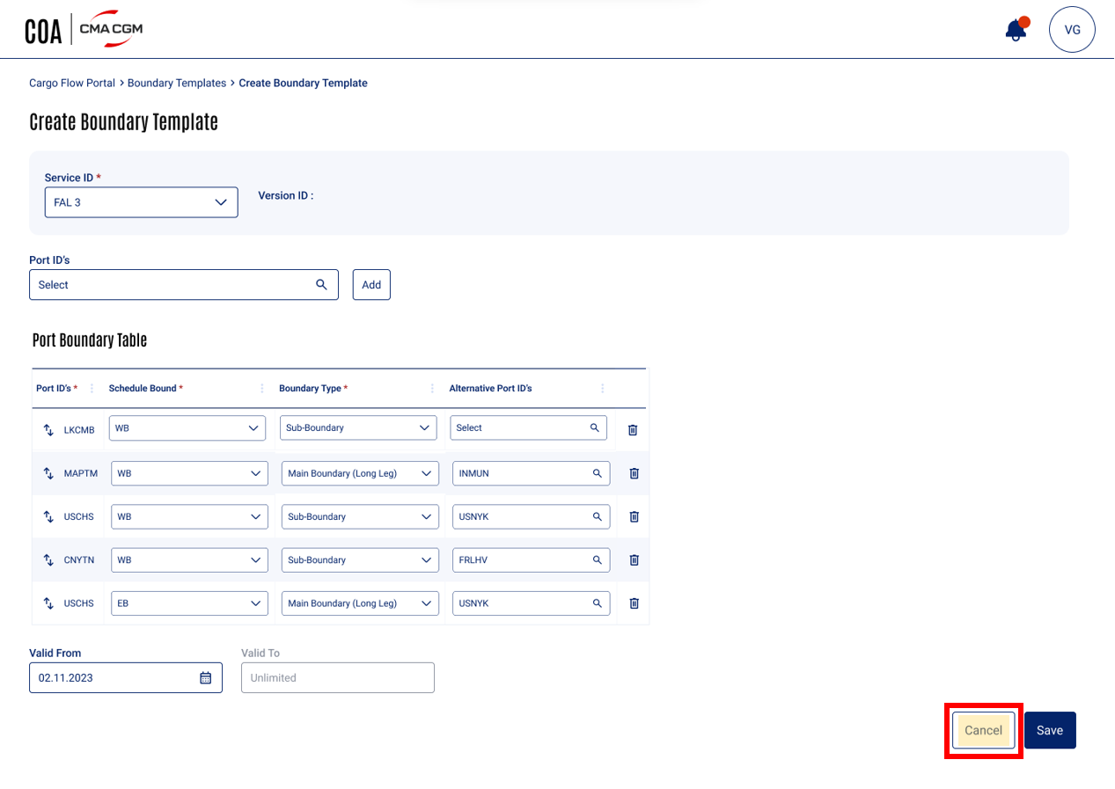

* Cancel creation of boundary template - confirmation message

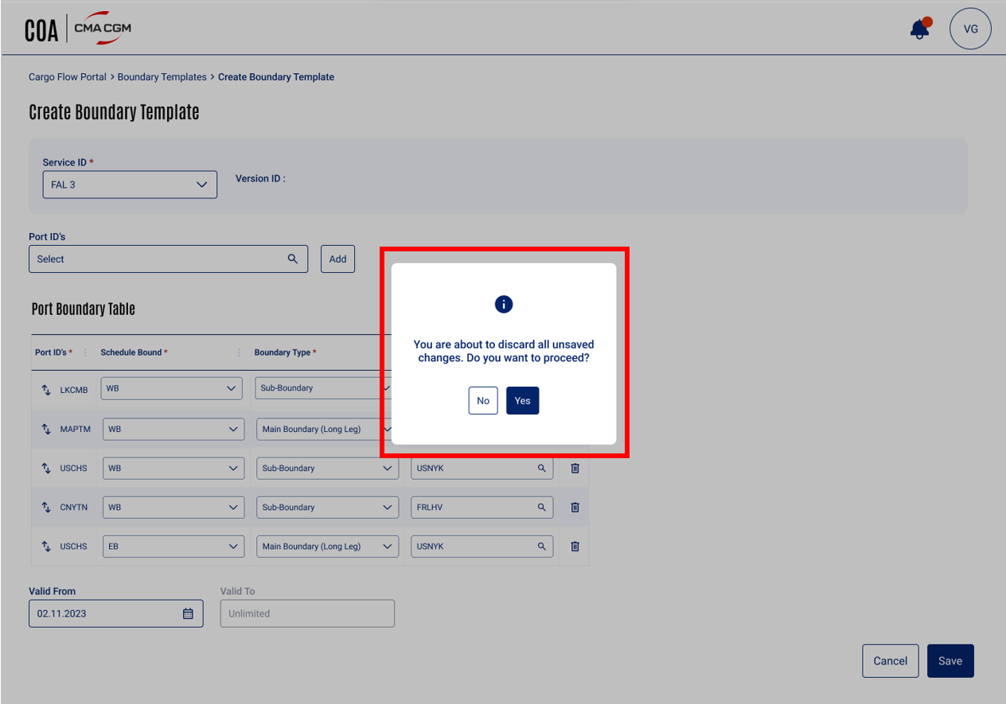

* Cancel creation of boundary template – if user clicks on yes button, he is directed to the boundary templates page.

* Saving the boundary template

* After all the validation checks are done by the system the boundary template and version id are successfully created

* Validation checks- same port can be setup as Sub-boundary or main boundary (Long Leg) but not on the same bound.

* Validation checks- same port can be setup as Sub-boundary or main boundary (Long Leg) but not both within the same bound - error message

* Validation checks- assign at least one main boundary (Long Leg) for each bound

* Validation checks - assign at least one main boundary (Long Leg) for each bound - error message

### Validation and Rules

Below are the **detail definitions** for **attributes**, button and error message in **Create boundary template.**

|  |  |  |  |  |  |  |  |
| --- | --- | --- | --- | --- | --- | --- | --- |
| **SR** | **Label** | **Description** | **F** | **A** | **D** | **List** | **Rules** |
| 1 | Service ID | Service ID is associated with the selected Service and will be present in the schedule | FA FN | M | E |  | BR03 |
| 2 | Version ID | Version ID will be generated by the system once the boundary template is saved | FN | M | R |  | BR15 |
| 3 | Port ID’s | The field to type or search the Port ID’s that will be a part of the boundary template in a particular sequence | FA | M | E |  | BR04 |
| 4 | Add | Button to add selected ports in the boundary template | BT |  | E |  | BR05 |
| 5 | Port ID’s column in table | This field will get automatically populated once the user adds the ports in the above port ID’s field | FA | M | D |  | BR07 |
| 6 | Schedule Bound | Segregation of a technical voyage into separate blocks that indicate the direction of the vessel sailing | FA | M | E |  | BR08 |
| 7 | Boundary Type | Every port in the port column will be marked as Main Boundary (Long Leg) or a Sub-boundary in the Boundary Template | FA | M | E |  | BR09 |
| 8 | Alternative Port ID’s | A particular port will be set as an Alternative Main Boundary or Alternative Boundary in case the business changes the actual main boundary or actual boundary. | FA | O | E |  | BR10 |
| 9 | Validity From | Validity Start date of the Boundary Template | DA | M | E |  | BR11 |
| 10 | Validity To | Validity End date of the Boundary Template which will always be pre-filled as ‘Unlimited’ | DA  FA | M | R |  | BR12 |
| 11 | Cancel | Button to Close the creation of the Boundary template at any time. | BT |  | E |  | BR13 |
| 12 | Save | Button to save the creation of the Boundary template | BT |  | D E |  | BR14 |
| 13 | Error messages | Error details in any field in Boundary template | FA | M | R |  | BR16 |

Legend

|  |  |  |  |  |  |  |  |  |
| --- | --- | --- | --- | --- | --- | --- | --- | --- |
| **Format** | CB | Check Box | **Attribute** | M | Mandatory | **Display** | D | Field disabled |
| FA | Field alpha | O | Optional | E | Field Enabled |
| FN | Field numeric |  |  | R | Read Only |
| LOV | List of Value |  |  | H | Hidden |
| DA | Date |  |  |  |  |
| BT | Button |  |  |  |  |
| DT | Date Time |  |  |  |  |

### Setups and configurations

* User authorization will be handled in a separate user story ALL-139 (Roles and authorization)

### Processing definition

Following business rules must be implemented:

|  |  |
| --- | --- |
| **ALL-35- Create a Boundary Template (part 1)** | |
| **BR01** | **Navigation to the Create Boundary Template Screen**   * After authorized user clicks on the Create Boundary Template button on Boundary templates page, the user should be directed to Create new boundary template screen. * The breadcrumb for the authorized user will be Cargo Flow Portal > Boundary templates > Create New Boundary Template.   A screenshot of a computer  Description automatically generated |
| **BR02** | **Boundary Template Screen Overview**   * The create screen will have the navigation breadcrumb displayed at the top. * The screen should have label ‘Create a Boundary Template’. * Attributes such as Service ID, Version ID, Port ID’s, Port boundary table, valid from, valid to, add button, cancel button and save button are available on the screen. * Port boundary table will have Port ID’s, Schedule Bound, Boundary Type and Alternative Port ID’s as columns.      * **Mandatory fields-**   + Service ID   + Port ID’s   + Valid from   + Schedule Bound (within the port boundary table)   + Boundary type (within the port boundary table) * Optional attributes   + Alternative Port ID’s (within the port boundary table) * Information: ‘Validity to’ will be displayed as unlimited |
| **BR03** | **Service ID**   * Only one service ID can be added in this field. * **User Input-** User has 2 options to input the data  1. Autosuggestion after 2 characters are typed in the field 2. Drop-down to view all service IDs and select from the list  * The list of service IDs displayed in the autosuggestions and the drop-down are from the schedule and are always displayed alphabetically sorted (A to Z). * If the user manually types the service ID which is not present in schedule, the field will be highlighted in red indicating that the input is not valid.      * When the user enters a service ID for which a boundary template already exist, an error message should pop-up saying “A boundary template already exist for the ‘Service ID’. Please click here to Edit”. Where Service ID is the service ID which caused the error. Note: Clicking on here should take the user to the Boundary Templates page     Example  Assume that a boundary template already exists for FAL 3 service and while creating a new boundary template the user enters FAL 3 in the Service ID field, the user will get the error message pop-up. |
| **BR04** | **Port ID’s field**   * Single port ID or multiple port ID’s can be defined in this field. * User Input - User has 2 options to input the data  1. **Option 1:** Autosuggestion after 2 characters are typed in the field and the relevant suggestions will appear in alphabetical order      1. **Option 2**: Search to view all the port ID’s from the master data in pop-up window by clicking on the lookup (magnifying glass) icon        * The list of port ID’s displayed in the autosuggestions and in the pop-up window are from the master data. * If the user manually types the port ID which is not present in master data, the field will be highlighted in red indicating that the input is not valid.      * The cross bar against the port ID can be clicked to clear the non-valid port as per master data. * Attributes of the autosuggestion list are * select all button * clear all button * list of 10 most relevant port IDs autosuggestions * cancel button * ok button      * When Clear All button is clicked, the checkboxes against the port ID’s from the autosuggestion list selected will be unticked and the selection will be cleared. * When Select All button in the autosuggestion list is clicked, all the port ID’s in the list will get selected. * When Cancel button is clicked, the autosuggestion list will close. * Once the user clicks on the OK button in the autosuggestion list, the list will close and the port ID’s field will reflect the selected port ID’s.      * Attributes of the view all port ID’s pop-up window are * search bar * select all button * clear button * a list of all the port ID’s in alphabetical order * checkbox against each port ID to select specific port ID’s * number of port ID’s selected out of all the port ID’s present in the list * cancel button * select button      * When Clear button in the pop-up window is clicked, the checkboxes against the port ID’s selected will be unticked and the selection will be cleared. * When Select All button in the pop-up window is clicked, all the port ID’s in the list will get selected. * When Cancel button is clicked, the pop-window will close. * Once the user clicks on the select button in the pop-up window, the pop-up window will close and the port ID’s field will reflect the selected port ID’s.      * User should be able to see at least the first 8 port ID’s out of the selected port ID’s in the port ID’s field. |
| **BR05** | **Add Button**   * When the ‘Add’ button is clicked, the Port ID column in the port boundary table will get populated in the same sequence selected and displayed in the Port ID field. * All the corresponding fields to Port ID column will appear in table for every Port ID. * Mandatory fields in the Port Boundary table will get highlighted in red. * The Port ID’s field will get cleared. |
| **BR06** | **Port Boundary table**   * The table will have 4 columns  1. Port ID’s 2. Schedule Bound 3. Boundary type 4. Alternative Port ID’s  * **Mandatory column-** Port ID’s, Schedule Bound and Boundary Type * **Optional column** – Alternative Port ID’s * Every port ID will have vertical swaps icon to rearrange the entire row. * At the end of every row there will be delete button to delete the entire row. |
| **ALL-244- Create a Boundary Template (part 2)** | |
| **BR07** | **Port ID’s** column in the port boundary table   * The port ID’s column will get automatically populated as per the logic explained in BR05. * It will be a non-editable field. |
| **BR08** | **Schedule Bound** column in the port boundary table   * There are only 5 values for this field as follows   + EB   + WB   + NB   + SB   + RT * Only one bound can be added in this field for every port ID (every row). * **User Input-** User can click the drop-down to view the bounds and select the bound from the list * Once the user gives valid input value in schedule bound field, it should no longer be highlighted in red.   Note: Schedule Bound reference data is a one time setup done in COA module. Following table structure needs to be defined in COA.   |  |  | | --- | --- | | **Schedule Bound** | **Bound defined in C-Voyage** | | EB | E | | WB | W | | NB | N | | SB | S | | RT | RT | |
| **BR09** | **Boundary Type** column in the port boundary table   * There are only 2 values for this field as follows   + Sub-boundary   + Main boundary (Long Leg) * **User Input-** User has 2 options to input the data   + Autosuggestion after 2 characters are typed in the field in alphabetic order   + Drop-down to view the boundary type and select from the list * Once the user gives input value in boundary type field, it should no longer be highlighted in red.   Note: Boundary type reference data is a one time setup done in COA module. |
| **BR10** | **Alternative Port ID** column in the port boundary   * It is an optional field in the port boundary table. * Only one alternative port ID can be added to this field for every port. * **User Input-** User has 2 options to input the data (similar to Port ID’s field feature in BR05)   + **Option 1**: Autosuggestion after 2 characters are typed in the field in alphabetic order and once the user clicks the port ID from the list the field gets populated.   + **Option 2**: Search to view all the port ID’s from the master data in pop-up window by clicking on the lookup (magnifying glass) icon (Similar to Port ID’s field with only exception being the user can select only one port and there won’t be checkboxes). Once the user selects the single port ID from the pop-up window and clicks on OK button, the field gets populated * The list of port ID’s displayed in the autosuggestions and the drop-down are from the master data. * If the user manually types the port ID’s which is not present in master data, the field will be highlighted in red indicating that the input is not valid. |
| **BR11** | **‘Valid From’** date   * **User Input-** User has 2 options to input the data   + Type in option   + Calendar icon to select the date * The Valid from date field should already reflect the date format i.e. DD.MM.YYYY      * The date should be also displayed in DD.MM.YYYY format in the template. Example: 23.06.2024      * The user should be able to enter current, past or future date in this field. * Once the user gives valid date, it should no longer be highlighted in red. If not, the field will continue to be highlighted in red. |
| **BR12** | **‘Valid To'** date   * The Valid to date is always set as ‘Unlimited’ * The user should not be able to edit this field. |
| **BR13** | **Cancel** button   * When cancel button is clicked, user confirmation message will pop-up with yes and no options.      * If Yes button is clicked, the user will be directed to the boundary templates page. * If No button is clicked, the user will come back to the create boundary template page with all data intact. |
| **BR14** | **Save** button   * Only if all the mandatory fields (optional fields if applicable) are without data entry errors and are filled by the user, the Save button will be active, else it will be inactive and greyed out. * On clicking the ‘Save’ button following check are executed   + Boundary definition rule check * **Boundary definition rule** check:   + I should not be able to set up one port as both Sub-boundary and Main Boundary (Long Leg) within the same bound i.e.; One port cannot be defined as both Sub-boundary and Main Boundary (Long Leg) in the same schedule bound. User should get the following error message if this criterion is not met “‘**Port ID’ cannot be defined as Sub-boundary and Main Boundary (Long Leg) in the same bound.**” Where port ID is the port ID that caused the error.  |  |  |  |  | | --- | --- | --- | --- | | Port ID’s | Schedule Bound | Sub-Boundary/Main Boundary (Long Leg) | Alternate Port ID’s | | CNSHA | NB | Sub-boundary |  | | HKHKG | NB | Sub-boundary |  | | SGSIN | NB | Sub-boundary |  | | CNSHA | NB | Main Boundary (Long Leg) |  | | NLRTM | SB | Sub-boundary |  | | DEHAM | SB | Sub-boundary |  | | FRDKK | SB | Main Boundary (Long Leg) |  |   User will not be able to save this template due to CNSHA being Sub-boundary and Main Boundary (Long Leg) within NB.   * I should not be able to set up only Sub-boundary, without main boundary (Long leg), within the same bound i.e., there should be at least one main boundary (Long Leg) per bound. User should get the error message if this criterion is not met “**Please assign main boundary (Long Leg) for ‘Bound’!**” Where bound is the bound that caused the error.  |  |  |  |  | | --- | --- | --- | --- | | Port ID’s | Schedule Bound | Sub-Boundary/Main Boundary (Long Leg) | Alternate Port ID’s | | CNSHA | NB | Sub-boundary |  | | HKHKG | NB | Sub-boundary |  | | SGSIN | NB | Sub-boundary |  | | NLRTM | SB | Sub-boundary |  | | DEHAM | SB | Sub-boundary |  | | FRDKK | SB | Main Boundary (Long Leg) |  |   User will not be able to save this template as there is no main boundary (Long Leg) defined for NB.   * I should be able to set up only main boundary (Long Leg) (s), without Sub-boundary(s) i.e.; users can create a template with all port ID’s marked as main boundary (Long Leg) for a given bound or all bounds.  |  |  |  |  | | --- | --- | --- | --- | | Ports | Schedule Bound | Sub-Boundary/Main Boundary (Long Leg) | Alternate Port | | CNSHA | NB | Main Boundary (Long Leg) |  | | HKHKG | NB | Main Boundary (Long Leg) |  | | SGSIN | NB | Main Boundary (Long Leg) |  | | NLRTM | SB | Sub-boundary |  | | DEHAM | SB | Sub-boundary |  | | FRDKK | SB | Main Boundary (Long Leg) |  |  * I should be able to set up more than one main boundary (Long Leg) within a bound i.e.; users can have as many port defined as main boundary (Long Leg) for each bound. Similar example to #3. * I should be able to set up more than one Sub-boundary within a bound. * I should be able to set up an alternative port as Sub-boundary or main boundary (Long Leg). Example,  |  |  |  |  | | --- | --- | --- | --- | | Port ID’s | Schedule Bound | Sub-Boundary/Main Boundary (Long Leg) | Alternate Port ID’s | | CNSHA | NB | Main Boundary (Long Leg) |  | | HKHKG | NB | Sub-boundary | MYPKG | | SGSIN | NB | Main Boundary (Long Leg) |  | | NLRTM | SB | Sub-boundary |  | | DEHAM | SB | Sub-boundary |  | | FRDKK | SB | Main Boundary (Long Leg) | FRLEH |  * If there are no error based on the above checks, boundary template is successfully created and user is redirected to boundary templates page with a record created and confirmation message “A new boundary template ‘Service ID’ has been created” on the screen. |
| **BR15** | **Version ID & Status**   * Version ID will be blank at the time of creation and will be automatically allotted by the system after successful creation of the boundary template. * It will be in the numeric format as XXXX eg. 0001, 0002, 0003, etc. * Version number is associated for each boundary template created individually i.e.; when a boundary template is created for first time version 0001 will be assigned to it. For example, if FAL 3 template is created it is associated to version 0001. And if user created a new template for FAL 4, version 0001 will be assigned to it.   **Status**   * ‘Active’ Status will be assigned once the template is successfully created. This can be viewed in the Boundary Templates page. |
| **BR16** | **Error and Confirmation Messages Placeholder**  Error messages will be displayed in a rectangular box in red colour, near the notification bell icon (Please refer the Mock-up screens for the position).   * Confirmation message will appear as pop-up with action button. |
| **BR17** | **Clicking on Breadcrumb**   * Breadcrumbs are provided to ease navigation. * If the user clicks on the breadcrumbs, user is prompted with a confirmation message “Are you sure you want to cancel the creation of the Boundary Template?”.      * If the user clicks Yes in pop-up, the user should be redirected to the page associated to the breadcrumb and the user will lose all the data from the create boundary template. * If user clicks on No, user stays on the same create boundary template screen with all the data intact. |
| **BR18** | **By & Timestamp**  There are two columns information related to each template that are auto populated when the template is created,   * Created by * Created timestamp   Fields are populated as follows,   * Created by: Username and User ID of the user performing the action. Note, need to discuss technically what can be displayed here. * Created timestamp: is the date and time when the record was created and is displayed as Month Date Year HH:MM:SS (system date & time) example Oct 11 2023 14:17:35   Here is an example:  Scenario: User is creating the template for the first time   |  |  |  |  |  |  |  |  | | --- | --- | --- | --- | --- | --- | --- | --- | |  | **Service ID** | **Version ID** | **Valid From** | **Valid to** | **Status** | **Created by** | **Created timestamp** | |  | FAL 3 | 0001 | 01-Feb-2024 | Unlimited | Active | Savli Tapre, 123456 | Oct 11 2023 14:17:35 | |
| **BR19** | **NFR**     |  |  |  |  | | --- | --- | --- | --- | | Scenario | Step/transaction | Parameter | NFR | | Refresh the Boundary template screen | Refresh screen | All fields | 1 sec | |

### Functional Test Cases

|  |  |  |  |
| --- | --- | --- | --- |
| **Test case #** | **Rule** | **Functional Test** | **Expected Results** |
| **ALL-35- Create a Boundary Template (part 1)** | | | |
| **TC1.0** | BR01 | * When the authorized user clicks on ‘Create Boundary Template’ on the Boundary Templates page | * User is redirected the Create Boundary template screen. |
| **TC2.0** | BR02 | * Check whether all the elements on the Boundary Template screen matches with the UX/UI Mock-ups. | * Refer section 2.6 UX/UI Designs |
| **TC3.0** | BR03 | * When the user starts typing in the service ID field | * Autosuggestions will be displayed in alphabetic order from the schedule after 2 letters are typed in the field |
| **TC3.1** | BR03 | * When the user selects a Service ID from the auto-suggestion list | * The service Id field will get populated. |
| **TC3.2** | BR03 | * When the user types the service ID in the field which is not present in schedule | * The cell will be highlighted in red which will indicate that the data is invalid. |
| **TC3.3** | BR03 | * When the user clicks on the drop-down option in the Service ID field | * He/she should be able to see all the service IDs from the schedule. |
| **TC3.4** | BR03 | * When the user selects a Service ID from the drop-down list | * The service Id field will get populated. |
| **TC3.5** | BR03 | * When the user enters/selects the Service ID for which a boundary template already exists | * User will get an error message saying “A boundary template already exist for the ‘Service ID’. Please click here to Edit” |
| **TC4.0** | BR04 | * When the user starts typing in the port ID’s field | * Autosuggestions will be displayed in alphabetic order from the master data after 2 letters are typed in the field |
| **TC4.1** | BR04 | * When the user ticks the checkboxes against the port ID’s from the auto-suggested list | * The checkboxes should get ticked indicating that the respective port IDs are selected. |
| **TC4.2** | BR04 | * When the user clicks ok button in auto suggestion list | * These port ID’s field should get populated in the sequence the port ID’s are selected. |
| **TC4.3** | BR04 | * When the user types the port ID in the field which is not present in master data | * The cell will get highlighted in red which indicates that the data is invalid. |
| **TC4.4** | BR04 | * When the user clicks on the search icon in the port ID’s field | * The pop-up window opens with the list of all the port ID’s present in the master data in alphabetical order. |
| **TC4.5** | BR04 | * When the user clicks on the checkboxes against a port ID or port ID’s from the pop-up window port ID list | * The checkboxes should get ticked indicating that these port ID’s are to be added to the port ID column in the boundary template. |
| **TC4.6** | BR04 | * When the user clicks on the select all option in the pop-up window port ID list | * All the port ID’s present in the list should get selected. |
| **TC4.7** | BR04 | * When the user clicks on the clear option in the pop-up window port list | * The checkboxes against the port ID’s selected will be unticked and the selection is cleared. |
| **TC4.8** | BR04 | * When the user clicks on the select button in the pop-up window port ID list | * These port ID’s field should get populated in the sequence the ports are selected |
| **TC5.0** | BR05 | * When the user clicks on the Add button | * The Port ID’s column should get populated in the same sequence the port ID were selected and displayed in the port ID’s field. * All the corresponding fields to port ID’s column should appear in table for every port ID. * Mandatory fields should get highlighted in red * The port ID’s field should get cleared. |
| **TC6.0** | BR06 | * When the user clicks on the vertical swap icon before the port ID’s to move the entire row | * It should allow the user to rearrange the entire row |
| **TC6.1** | BR06 | * When the user clicks on the delete button at the end of the row | * The entire corresponding row will get deleted. |
| **ALL-244- Create a Boundary Template (part 2)** | | | |
| **TC7.0** | BR07 | * Verify the behaviour of the Port ID Column in the port boundary table | * This will be a non-editable field. |
| **TC8.0** | BR08 | * When the user clicks on the drop-down option in the schedule bound field | * He/she should be able to see all the 5 bound options in the list |
| **TC8.1** | BR08 | * When the user selects a schedule bound from the drop-down list | * The bounds field will get populated. |
| **TC9.0** | BR09 | * When the user types in the boundary type column | * Autosuggestions will be displayed in alphabetic order after 2 letters are typed in the field. It will have only 2 values ‘Sub-boundary’ and ‘Main Boundary (Long Leg)’ |
| **TC9.1** | BR09 | * When the user clicks on the drop-down option to select the boundary type | * Drop-down list will open, and he/she will see only two options i.e. ‘Sub-boundary’ and ‘Main Boundary (Long Leg)’ from which the user will have to choose the boundary type. |
| **TC10.0** | BR10 | * When the user starts typing in the Alternative port ID’s field | * Autosuggestions will be displayed in alphabetic order from the master data after 2 letters are typed in the field |
| **TC10.1** | BR10 | * When the user clicks on one of the alternative port ID’s from the auto-suggested list | * The autosuggestion list will close and alternative port ID field will get populated with the selected port. |
| **TC10.2** | BR10 | * The user types in the alternative port ID’s field, which is not present in the master data | * The cell will be highlighted in red which will indicate that the data is invalid. |
| **TC10.3** | BR10 | * When the user clicks on the search icon in the alternative port ID’s field | * The pop-up window opens with the list of all the port ID’s present in the master data in alphabetical order. |
| **TC10.4** | BR10 | * When the user clicks on one of the alternative port ID’s from the pop-up window | * The respective port ID gets selected. |
| **TC10.5** | BR10 | * When the user clicks ok button from pop-up window | * The pop-up window will close and alternative port ID field will get populated with the selected port. |
| **TC11.0** | BR11 | * When the user clicks on the calendar icon in Valid from date field | * The calendar should open in which the user can select any past, current or future date and the field should get populated in the format DD.MM.YYYY eg. 28.06.2024 |
| **TC11.1** | BR11 | * When the user types in Valid from date field | * The user should be able to type any past, current or future date in the format DD.MM.YYYY eg. 28.06.2024 |
| **TC12.0** | BR12 | * Check the Valid to Date field | * The field will be pre-filled as Unlimited and will be non-editable. |
| **TC13.0** | BR13 | * When the user clicks on the Cancel button | * A pop-up window will display a confirmation message with Yes and No option. Refer BR13 |
| **TC13.1** | BR13 | * When user clicks on Yes button | * The user will be directed to the boundary templates page |
| **TC13.2** | BR13 | * When user clicks on No button | * The user will come back to the create boundary template page with all data intact. |
| **TC14.0** | BR14 | * When the user clicks on Save button after entering all the mandatory details | * The system will do validation check and if there are no errors, the user will be directed to Boundary templates page where the template is successfully created, and the version ID is generated. Refer BR14 for the success message. |
| **TC14.1** | BR14 | * When the user clicks on Save button without filling data in the mandatory fields | * The save button should be greyed out and disabled. |
| **TC14.2** | BR14 | * When the user sets up one port as both ‘Sub-boundary’ and ‘Main Boundary (Long Leg)’ within the same bound, fills all other fields and clicks on save | * He/she should receive an error message saying, “‘Port ID’ cannot be defined as ‘Sub-boundary’ and ‘Main Boundary (Long Leg)’ in the same bound.” Refer BR14 for details. |
| **TC14.3** | BR14 | * When the user sets up only Sub-boundary, without main boundary (Long leg), within the same bound, fills all other fields and clicks on save | * He/she should receive an error message saying, “Please assign main boundary (Long Leg) for ‘Bound’!” Refer BR14 for details. |
| **TC14.4** | BR14 | * When the user sets up only main boundary(s), without Sub-boundary(s), fills all other fields and clicks on save | * The user should not get an error message and after all the other validation checks are done the template should be successfully created. |
| **TC14.5** | BR14 | * When the user sets more than one main boundary within a bound, fills all other fields and clicks on save | * The user should not get an error message and after all the other validation checks are done the template should be successfully created. |
| **TC14.6** | BR14 | * When the user sets more than one Sub-boundary within a bound, fills all other fields and clicks on save | * The user should not get an error message and after all the other validation checks are done the template should be successfully created |
| **TC15.0** | BR15 | * Test the Version ID creation by saving the boundary template | * The version ID will be automatically allotted by the system after successful creation of the boundary template. Refer BR15 for the format |
| **TC16.0** | BR16 | * When the user gets an error message | * The save button should be disabled and greyed out. |
| **TC16.1** | BR16 | * Test the confirmation message | * Pop-up window will appear with the confirmation message and yes and no options |
| **TC17.0** | BR17 | * When the user clicks on the breadcrumbs | * A pop-up window will display a confirmation message with Yes and No option. Refer BR17 for the message |
| **TC17.1** | BR17 | * When user clicks on Yes button | * The user will be directed to the boundary templates page |
| **TC18.0** | BR18 | * When the boundary template is successfully created | * Created by and Created timestamp will get auto populated. Refer BR19 for details |

# - Technical Details (Optional)

Technical solution will be decided by Dev team.

- End of document –